PM Gati Shakti
- Program
PM Gati Shakti National Master plan (NMP) was launched on 13th October 2021 for providing multimodal connectivity infrastructure to various economic zones. Cabinet Committee on Economic Affairs (CCEA) accorded approval for the implementation of PM GatiShakti National Master Plan on 21st October 2021.
- Launched to break the silo and to integrate all the existing/planned initiatives of the various Ministries/Departments being undertaken for better synergy
- To holistically integrate all the multimodal connectivity projects and remove missing gaps for seamless movement.
- DPIIT is entrusted with a responsibility of coordination among various infrastructure Ministries and to undertake required functions.
- Aim

- Aims to create “Next Generation Infrastructure”.
- Establish synergies among different ministries during the planning itself.
- Align timelines of various projects through efficient planning

- Six Principles of PM Gati Shakti

The NMP is developed based on six key principles viz. integrated development, multimodality, last mile connectivity, reduce ecological impact, expedited land acquisition, and minimized clearance.

- Institutional Framework- Three-Tier Institutional framework

- Empowered Group of Secretaries (EGoS)- EGoS chaired by Cabinet Secretary and includes 20 members: Secretaries of 8 infrastructure ministries and 12 Secretaries from other relevant ministries.
- To review, consider and approve any changes in Master Plan

- Network Planning Group -An Integrated Multimodal Network Planning Group (NPG) with heads of Network Planning Division of all connectivity infrastructure Ministries & Departments
- To examine proposals and ensure unified planning, integration and optimization
- To monitor all developments of NMP for project planning purposes
- All the projects costing more than Rs 500 cr are to be appraised by NPG.

- Technical Support Unit- Group of Domain/Subject Matter Experts within DPIIT.
- To assist logistic division in performing its role as the PM Gati Shakti Secretariat

- Gati Shakti – Digital Platform (Technologies)

The NMP has been developed as a “Digital Master Planning Tool” by BISAG-N (Bhaskaracharya National Institute for Space Applications and Geo-informatics), Gandhinagar.

- Prepared in dynamic Geographic Information System (GIS) platform with a provision of real time updation
- Built on Open-source technologies and hosted on MEGHRAJ (GoI Cloud)
- Used satellite imagery available from ISRO and base maps from Survey of India

- Ministries/Departments/State Governments on boarded
On boarded 44 Central Ministries and 36 States/UTs and a total of 1614 data layers have also been integrated
- Comprehensive master plan mapping all existing/planned initiatives of Ministries
- Ministries to provide data layers and attributes for existing/planned infrastructure/initiatives
- Planning through NMP portal and the tools available

- Flowchart- Planning of Railways Project

Possible railway line augmentation- New Line, Doubling or Gauge conversion
Doubling and gauge conversion typically follow the existing alignment, however in case of doubling/multitracking there may be a possibility to plan the railway line on new alignment specially in the highly habitated areas/congested yards.
Thus, to cover the entire activities that that are required to be followed on BISAG/PM Gati Shakti portal, activities pertaining to new line is being considered. Three types of projects are possible as far as augmentation of the railway line is concerned namely double, gauge conversion and new line. While the alignment of the doubling and gauge conversion is normally done along the existing line. Typically for gauge conversion there is no possibility to look out for the separate alignment, however in case of doubling/multitracking there may be the possibility where the new alignment may be looked out particularly in the congested areas due to rapid urbanization and there is no possibility for undertaking the doubling/multitracking due to high habitation area.
The present flowchart only covers the new alignment as it provides comprehensive planning of the railways project which may be vary depending upon the requirements and type of the line proposed to be augmented.

Planning of new railway line
- Three possible alignments are to be identified as per toposheets
- PM Gati Shakti portal may be used for the identification of the most suitable alignment by avoiding the “No Go area” and at the same time provide connectivity to all the major economic nodes located in the proximity to the project section.
- DPR preparation module tool
- O-D tool
- Select origin and destination (O-D)
- Tool shows the shortest (straight) route possible between the selected O-D along with coordinates (Latitude and Longitude)
- Modify the straight alignment prepared in previous step as per the requirement
- Tool generates the chainages at defined interval, curves at selected points and Right of Way (ROW) as per the width provided
- Crossing option in O-D tool provides details of roads, rail line, forest, canal, sanctuary, mining area, social nodes which crosses RoW. It helps in identifying the utilities lying within ROW to be shifted with location details
- Tool show land plans and generate land acquisition report with details of Government, private and forest land required to be acquired (Few states have only uploaded land)
- Various Ministries upcoming and existing projects can be seen along alignment and planning bridges, NOC from departments, Utility shifting etc. can be planned while finalizing longitudinal sections.

- Usage of Portal

- Social infrastructure

- State governments using NMP portal for planning of various social sector infrastructure like: Anganwadis, Schools, Health Infrastructure, etc.
- State of Gujarat was able to identify land for the construction of new anganwadis in the district of Surendranagar.
- Through the usage of gap identification tools on the NMP for the purposes of the state, district boundaries, road networks, river and water bodies in the region can be identified.
- The tools helped in identification of suitable land for the construction of the Anganwadi in the Khelri village.

- Railway Projects- Planning of Technical Aspect-New BG Jalna- Khamgaon
- Alignment Finalization- Tool Used (Go/No Go Tool and dynamic alignment tools)
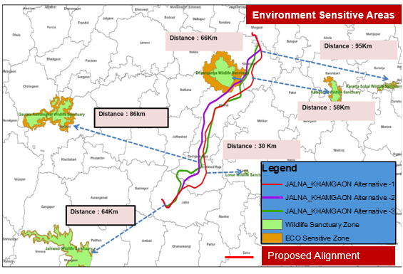
- Uploading of the KML file with three options
- Assessed the No Go area such as Defence land, Wildlife sanctuary, Mines, Forest land, Ecological sensitive zone, and Habitation areas
- Alignment was found to be close to Dnyanganga & Lonar Wildlife Sanctuaries
- Using NMP, 3 alignments were analyzed with buffer zone & dynamic alignment tools and wildlife areas were avoided

- Land Acquisition
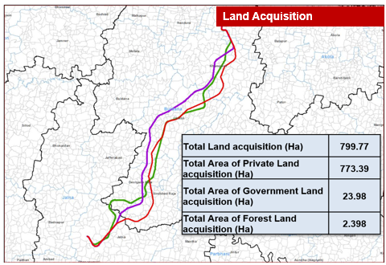
- Land plans and Khasra details were studied
- Identified the land ownership such as Private/Government/ Forest Area through NMP
- Based on the selected alignment and khasra details, initiated the discussion with the district authorities/State Authorities/Forest Authorities as the case may be, for acquisition of land during the project development stage itself. This will speed up land acquisition process post sanctioning of the project.

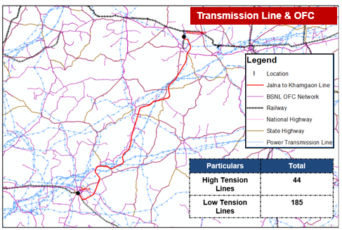
- Utility shifting
- NMP portal facilitated in identification of transmission lines and OFC networks that is crossing the proposed alignment
- Enabled better visualization and facilitated stakeholders’ consultations for optimal alignment planning.
- Discussions may be initiated during project development stage for early shifting of the utilities

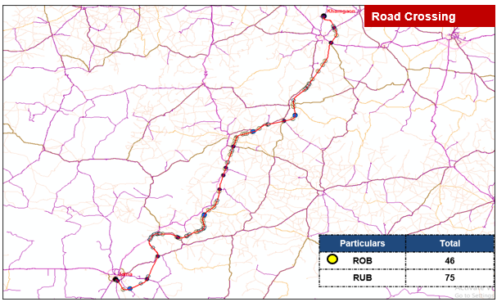
- Planning of ROB/RUB
- NMP facilitated integrated planning by mapping road networks and optimizing ROB/RUB locations in discussion with MoRTH, NHAI and State Road Department.
- Total 121 Road Over Bridge (ROB) and Road Under Bridge (RUB).
- Can be useful in identification of intersection with waterbodies/rivers accordingly facilitates in planning of bridges also.

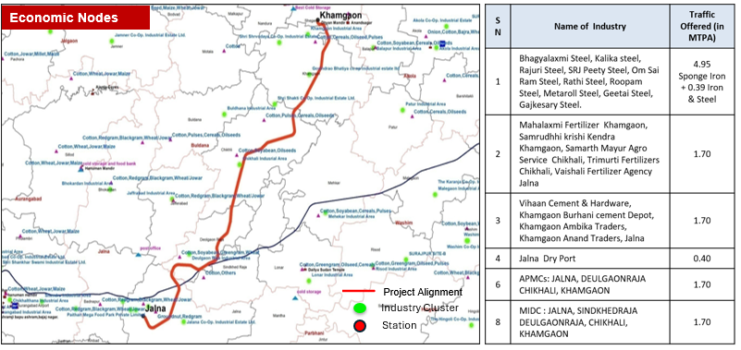
- Economic Nodes and Last Mile Connectivity
- The alignment is in close proximity to key economic nodes like steel plants, cement, fertilizers and agro-industries.
- Route optimized to enable last mile connectivity to these major industries.

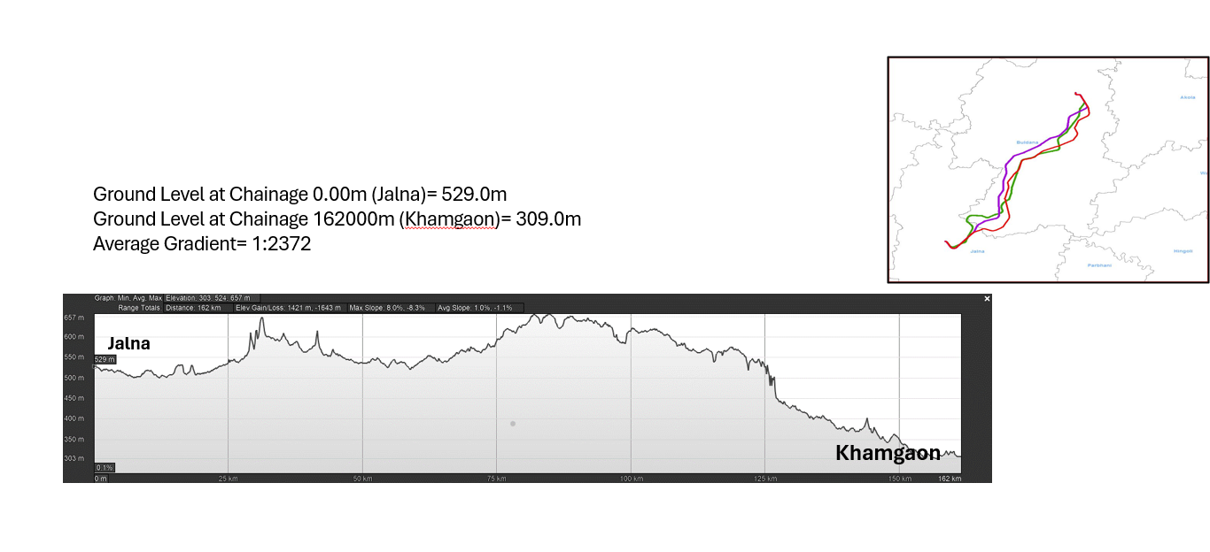
- L Section

